Deep learning term:
- Core Concepts:
Term | Meaning
Neuron | Basic unit of a neural network that processes and passes information
Layer | A collection of neurons; input, hidden, or output layer
Weights | Parameters that connect neurons and adjust during training
Bias | Additional parameter to shift activation; helps with flexibility
Activation Function | Determines if a neuron should be "activated" or not
Epoch | One full pass through the training dataset
Batch Size | Number of samples processed before model weight update
Iteration | One update of weights (per batch)

2) Model Training Terms:
Term | Meaning
Loss Function | Measures the error between predicted and actual output
Optimizer | Algorithm to minimize the loss (e.g., SGD, Adam)
Backpropagation | Process of updating weights based on error gradients
Gradient Descent | Optimization algorithm that updates weights using gradients
Learning Rate | Step size for each weight update

3) Model Types & Layers:
Term | Meaning
Dense Layer | Fully connected layer; each neuron connects to all in previous layer
Convolutional Layer (Conv2D) | Used for image processing, extracts spatial features
Pooling Layer | Reduces spatial dimensions (MaxPooling, AvgPooling)
Dropout | Regularization technique; randomly deactivates neurons to prevent overfitting
Flatten Layer | Converts 2D data to 1D before passing to Dense layers
Recurrent Layer (RNN, LSTM) | Used for sequential data like text or time series

4) Output & Evaluation Terms:
Term | Meaning
Accuracy | Percentage of correct predictions
Precision | True Positives / (True Positives + False Positives)
Recall | True Positives / (True Positives + False Negatives)
F1 Score | Harmonic mean of precision and recall
Overfitting | Model performs well on training but poorly on test data
Underfitting | Model performs poorly on both training and test data
Validation Set | Used to evaluate the model during training
Test Set | Used to evaluate final model performance after training

1) What is an Activation Function in Neural Networks?
An activation function in a neural network determines whether a neuron should be activated (fire) or not.
It adds non-linearity to the model, enabling the network to learn complex patterns and relationships in the data.
Without activation functions, a neural network would behave like a linear regression model, no matter how many layers you add.
Common Types of Activation Functions:
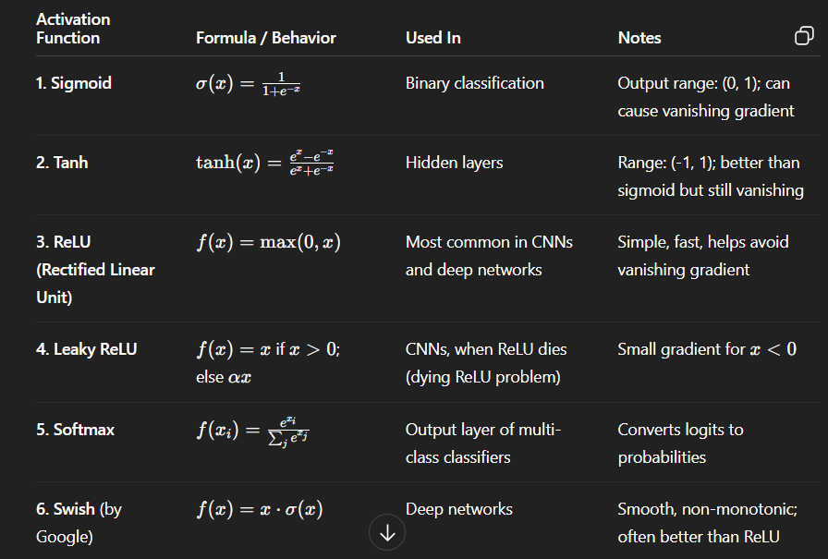
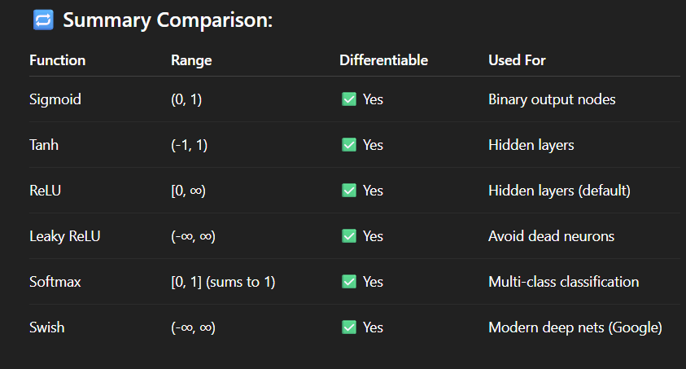

What is a Loss Function in Neural Networks?
A loss function is a mathematical function that measures the difference between the predicted output of a model and the actual/true output (ground truth).
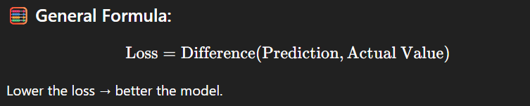
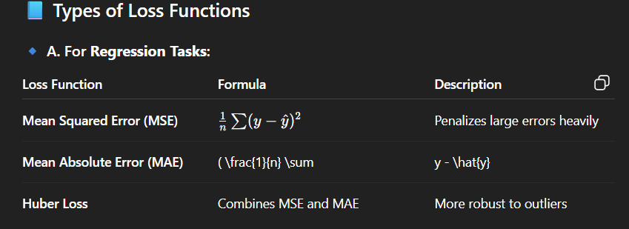

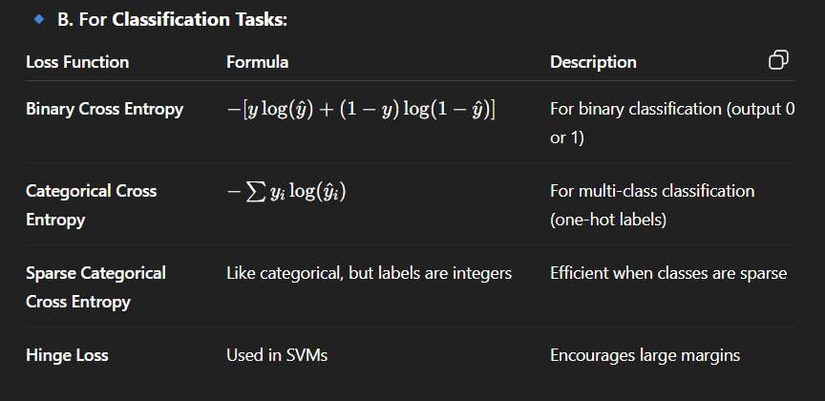

Quick Summary Table:
Task Type | Common Loss Functions
Regression | MSE, MAE, Huber Loss
Binary Classification | Binary Cross-Entropy
Multi-Class Classification | Categorical Cross-Entropy

